**Ideation Phase**

**Define the Problem Statements**

|  |  |
| --- | --- |
| Date | 27 June 2025 |
| Team ID | LTVIP2025TMID59821 |
| Project Name | Pattern Sense: Classifying Fabric Patterns using Deep Learning |
| Maximum Marks | 2 Marks |

**Customer Problem Statement Template:**

Manual fabric pattern classification in the textile and fashion industry is time-consuming, error-prone, and lacks consistency. Traditional inspection methods struggle to scale with increasing production demands and often misidentify subtle differences between patterns.  
The **Pattern Sense** project applies transfer learning to develop an automated, image-based classification system that accurately distinguishes between different fabric patterns like floral, stripes, polka dots, and more.This automation reduces human error, speeds up quality control, improves production efficiency, and ensures consistent labeling—ultimately benefiting manufacturers, retailers, and designers.

Reference: <https://miro.com/templates/customer-problem-statement/>

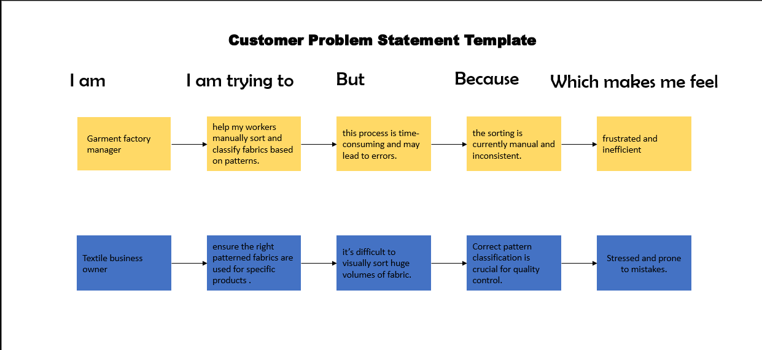

|  |  |  |  |  |  |
| --- | --- | --- | --- | --- | --- |
| **Problem Statement (PS)** | **I am (Customer)** | **I’m trying to** | **But** | **Because** | **Which makes me feel** |
| PS-1 | Garment factory manager | |  | | --- | | Helps my sorters  sort patterns. |  |  | | --- | |  | | This process is time-consuming and may lead to errors. | Sorting is currently manual. | like frustrated |
| PS-2 | Textile business owner | ensure the right patterned fabrics are used for specific products and batches | It is difficult to visually sort huge volumes of fabric. | Correct pattern classification for quality control. | like frustrated to sort and prone to mistakes. |